**Abstract:**

An open-source and mainly 3-D printable hand prosthetic is to be developed by a team of five Mechanical Engineering seniors in a student-driven design project. The hand prosthetic will combine the technologies of existing 3-D printed hands with the concept of granular jamming to maintain firm grip at a fraction of the cost of existing prosthetics. The hand will allow for performance of relatively low strength, high dexterity, household tasks. To meet this goal, a background on types and incidences of amputation has been established, as well as on state-of-the-art designs in both professional and hobbyist prosthetics. Potential users of the product have been identified, and some original research on hand usage has already been completed. Additionally, conceptual designs have been generated and compared, resulting in a generalized plan for future hand design, and a plan for future testing and development has been generated.

**Project Goals:**

The main goal of this project is to create an open-source, affordable, and high-functioning prosthetic hand. The hand should be task-oriented and able to achieve household activities requiring relatively low strength and high dexterity. It should be similar in size and weight to a human hand, and look relatively similar as well, to make it appear relatable and human.

Primary task goals are as follows. Firstly, the hand should be able to pick up and put down objects of varying sizes and shapes. It should also able to open and close doors of varying types, such as lever style doors, knob style doors, and fridge doors. To maintain some level of relatability (and avoid venturing too far into the uncanny valley), it should be able to perform simple gestures such as pointing, or giving a “thumbs-up” gesture. It should also be able to use a mouse. Computers have become a massively important facet of society, and while a keyboard would prove too complex given the budget and timeframe, a mouse can certainly be used to perform most computer-based tasks (especially when paired with existing software meant to facilitate typing with the mouse). Finally, the hand should be able to use occupational therapy tools, such as cutlery and pencils or pens. Again, while it may prove too complex to use traditional utensils, the larger size of an occupational therapy device combined with the abilities of the hand should offer a level of autonomy that the user would not have had otherwise. If most or all of these task goals can be completed, the project may be considered a success.

Secondary goals are slightly more complex. Some examples of secondary goals are ability to use touchscreens (via a conductive layer on the thumb and index finger), ability to open cans, achieving rotation, primitive myoelectric control (for open/close), and allowing for joint locking so that certain positions can be held while only one joint is moved (useful for certain tasks, such as using a mouse or playing a note on a keyboard). If some or any of these goals can be achieved, it would add a lot of functionality to the project, but these goals are not a priority, but are instead seen as a way to move the project forward if primary goals have already been achieved.

**Conceptual Designs:**

To simplify the design process, conceptual design ideas were split into three categories: Hand ideas, which related to the rigid 3-D printed components of the hand; granular jamming ideas, which related to the soft granular jamming pads and accompanying pneumatic assembly; and other considerations, which acted as a catch-all grouping for ideas which were valuable, but did not fit into the other two categories.

In the hand ideas category, methods were considered for the four subcategories: moving joints, holding position, straightening the hand, and sensing grip. For moving joints, pneumatics, motors, and cabling systems were all considered.

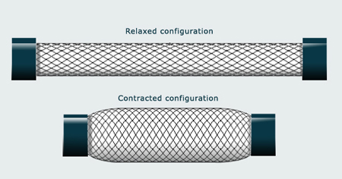

**Figure 1:** Pneumatic Muscle example. Filling the muscle with air causes it to contract, getting larger in diameter and decreasing in length. This would be attached to a cabling system which would then pull the fingers inward.

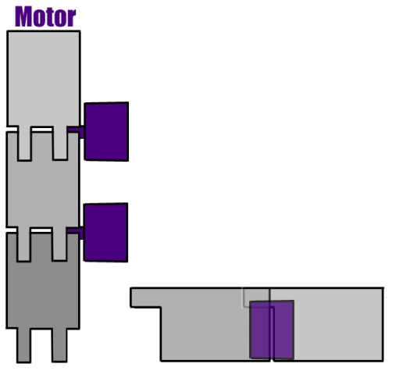

**Figure 2:** Motor System example. Each joint is run by an individual motor, allowing for a full range of motion.

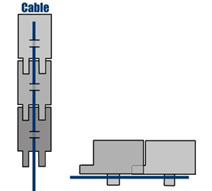

**Figure 3:** Cabling System example. The cable runs along the underside of the finger, which hinges near the center. Pulling on the cable generates a downward force and pulls the finger inward uniformly to the palm. These cables can be attached to either pneumatic muscles or to motors housed in the forearm.

An additional permutation was also considered, to combine motors at the base of fingers with cables running along their lengths. This would hopefully add a little dexterity and allow for only the joint at the base of the finger to be moved. To hold joints static it was considered firstly if it was important enough to warrant spending time and resources designing around static joint options, and secondly, how to do it. The ideas of gear teeth at joint interfaces, and external joint locks were both considered. To straighten the hand, the idea of using long elastics, short elastics (at joints only), flat springs, and opposing cables were all explored.

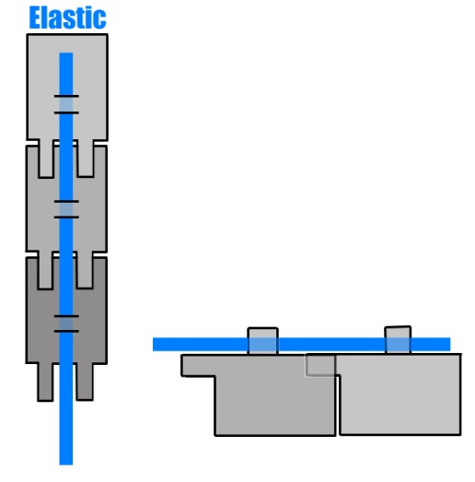

**Figure 4:** Long elastic example. The elastic runs along the top of the finger, opposing closing motion, and anchors somewhere on the back of the hand. That way when the hand is in a resting state, the fingers will be straight. Teeth on the top of each finger mesh and ensure that the finger will not hyperflex when relaxed, via mechanical interference.

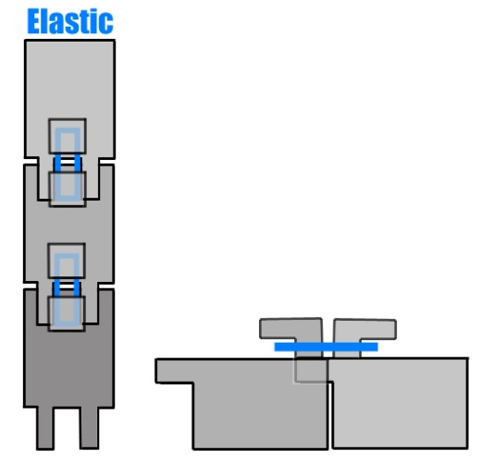

**Figure 5:** Short elastic example. This elastic is only present at joint interfaces, and is clipped around an outcropping that flares out to ensure that it will not slide off. Teeth on the top of each finger mesh and ensure that the finger will not hyperflex when relaxed, via mechanical interference.

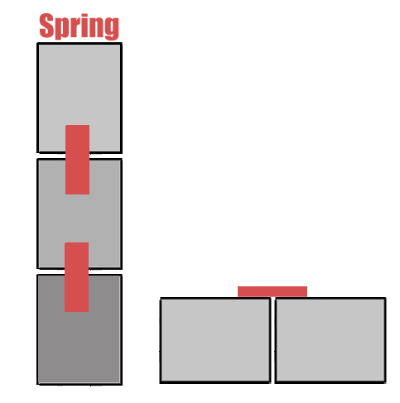

**Figure 6:** Flat spring example. The flat springs are thin pieces of metal that straighten out when not under force. This ensures that the resting state of the fingers will be straight. Intermeshing teeth are not necessary for this design.

The opposing cable design would simply consist of a set of cables running along the top of the finger (rather than the underside as the closing cables would). Pulling on these cables would pull the fingers upward and therefore straight. Running the two cables against each other would keep the fingers totally rigid. To sense grip, it was considered that there could be no grip sense, and a vacuum activated via button, a bump sensor under the granular jamming pads, and an encoder paired with the servo motors to read if they had reached a stall state.

Ideas considered for the granular jamming portion made up the second conceptual design category. Here three subcategories were considered: Granular jamming material, housing material, and layout. For granular jamming material, three options were considered: sand, coffee grounds (a material that has been previously shown to work), and plastic stuffing materials, as one would see in a weighted stuffed animal. Housing materials considered included balloons (another material that had been proven to work) and slip-cast silicone (similar to what is used in animatronics and costuming applications).

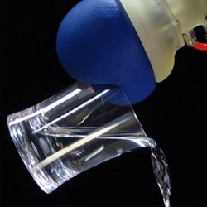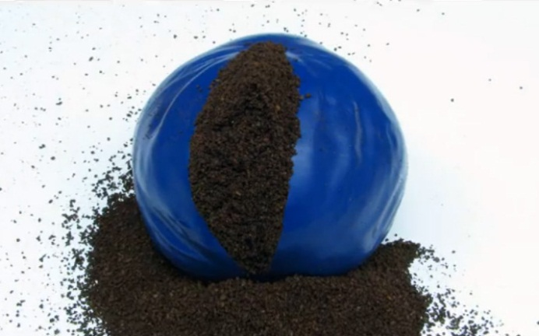

**Figure 7:** A granular jamming gripper can be as simple as a balloon filled with coffee grounds, as shown here.

For layout, two categories were considered: Firstly whether pads should be interconnected, or if they should each have a line that individually would connect to the main line (and through this, the vacuum), and what the physical layout for the pads should be (i.e. having pads on each fingertip and the palm, pads on the 3 sections of the finger and the palm, or having pads on two finger sections and the palm).

**Chris Wallace’s stuff goes here**

Ideas considered for the “Other Considerations” portion were good ideas that did not fit into either hand or granular jamming categories. Ideas considered under “Other Considerations” included: size, use with touch screens, nails, and printing in polycarbonate plastic. Size was deemed extremely important for the project, as the hand could not be significantly smaller, larger, or heavier than a real human hand. Touch screen usage could be solved with a conductive fabric and was considered a secondary goal, as was the idea of adding prosthetic nails (which are used for certain tasks, such as opening cans).

**Where should we/should we at all/who should discuss hand size research?**

**Features and Comparisons of Conceptual Designs:**

These designs, once generated, were then compared via decision matrices to see which would be the most effective solutions. This would ensure that the best solutions could be selected and that the design could move forward from vague descriptions of how something might work into a stage in which testing and further research could be done.

First to be considered was the joint locomotion. Pneumatic muscles would most accurately mimic the way that a real human arm works, but are also fairly complex, expensive, and possibly difficult to control (since no group members has prior practical experience with pneumatics, learning control methods in addition to doing them may be difficult).

Motors at each joint would have had a full range of motion on each finger joint (to the point that they could easily drive the joint into itself—a distinct disadvantage) but they are also expensive, bulky, and very complex (since now in order to control the hand it would be necessary to keep track of around 30 different motors).

The cable-and-motor setup would be relatively simple (turn a motor to effectively shorten a cable, drawing a finger in towards the palm), cheap (up to five motors would be required to run the fingers—a huge improvement over 30), small, since the cables take up a negligible amount of space and the motors can be housed where there is more space in the forearm, and achieve a fairly accurate range of motion—only problem being that a human can lock two joints and move just one (such as when typing or playing the piano), and the cables would all move fingers uniformly.

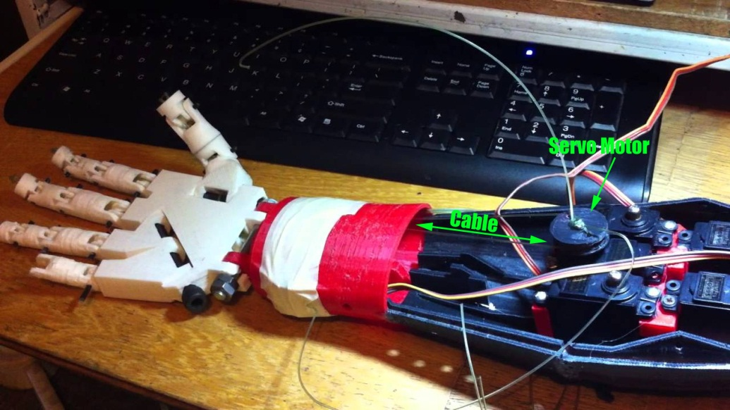

**Figure 8:** An existing hand design demonstrating the cable-and-motor motion system.

The idea of combining a motor at the base of the finger with cables running along its length was also considered. This base motor could correct the locking-joints problem (by just moving the base of the finger) but the added expense, bulk and complexity (since moving the first joint effectively shortens the cable, so the cable motor would have to run backwards to accommodate the finger base motor whenever base motion was required) made this solution less than worthwhile. Below is the decision matrix for all of the options considered:

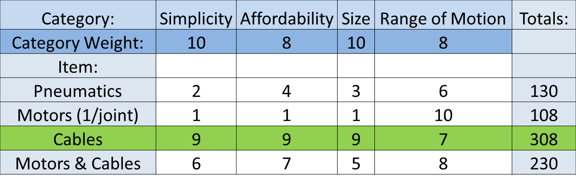

**Figure 9:** Joint motion decision matrix.

Using a cabling system paired with motors, however, opens up a number of other possibilities: namely the possibility of including one cable for every finger, sharing a cable between the ring and pinky fingers, having one cable per joint in the hand, and having one cable per every two joints in the hand. Having one cable per finger is fairly self-explanatory. Each finger is capable of independent control via a motor in the forearm. Combining the ring and pinky fingers onto one motor would decrease complexity without sacrificing a lot of usability (since the two fingers are actually linked in a human hand). One cable per joint would allow the fingers to “wrap around” objects more efficiently, since the one cable per finger method would just cause the fingers to move uniformly in a C-shape, and 1 cable/2 joints would achieve the same as 1 cable/joint whilst being less complex (and a little less effective). Ultimately however it was concluded that the grip improvement of the granular jamming pads would more than make up for the C-shape of a single-cable finger, and that having five cables was not so much more complex or expensive than having four that it was worth eliminating one. The decision matrix for this design is shown below:

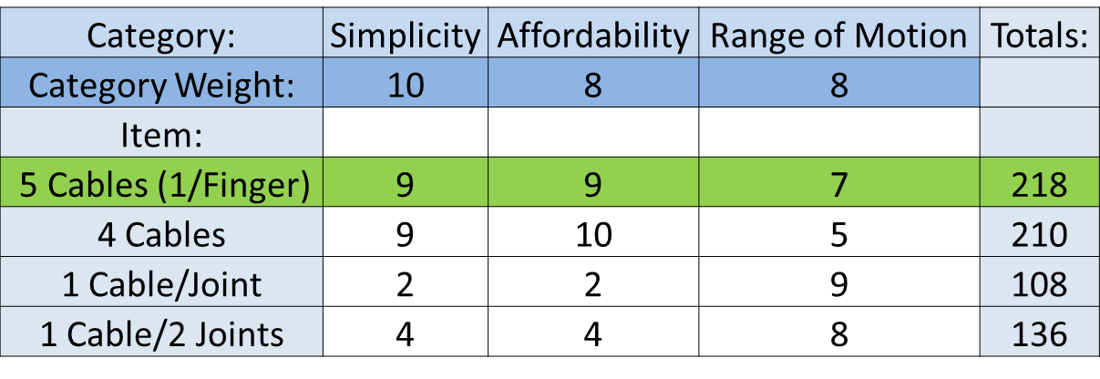

**Figure 9:** Cabling ideas decision matrix.

Straightening the hand is important because with cabling it would not have a resting state like a human hand does, and instead would move around loosely as the arm was moved, making it difficult to position the fingers in useful ways to grip things. As a result it was decided that the resting state of the fingers should be straight. The four methods considered to straighten the hand were large elastics, small elastics, flat springs, and a second set of cables. The large elastics would do a fine job of keeping the hand straight, but would also incapacitate the entire finger if they snapped, and every time one broke it would be necessary to replace it by threading it back through its housing. Small elastics help to negate this problem by only being at the joints. That way if one snaps only that joint is incapacitated and they would also be simpler to replace. Flat springs would require less design work, since elastics require plastic outcroppings to keep from hyperextending the fingers all of the time, and would be much more reliable than elastics, but are also harder to repair and more expensive. A second set of cables would allow for hyperflexation when appropriate (and would keep the hand straight when not) but they would also double the number of motors necessary to run the hand, adding a lot of complexity and cost. The decision matrix for hand straightening ideas is shown below:

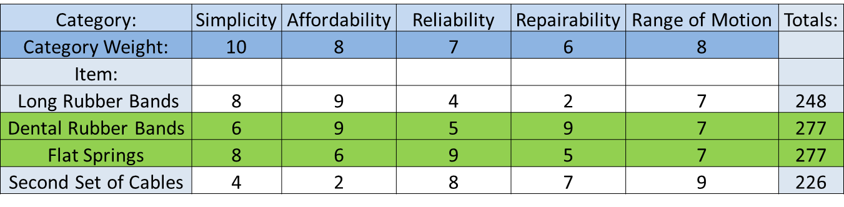

**Figure 10:** Straightening ideas. Both the dental rubber bands and flat springs proved to be reasonable solutions, so both will be tested (time allowing).

The final consideration for hand mechanics was grip sense. This would sense when the hand has come in contact with an object and can stop closing. The three options considered were user controlled button, bump sensors under the granular jamming pads, and encoders on the servos that could communicate when a motor was stalled, something that occurs when it has collided with an object and cannot move. The user button, while the simplest and cheapest solution, was rejected because it assumed the user had use of their other arm. Bump sensors, conversely, were too expensive and complex to really be feasible. The number of required sensors would have to be tested, as well as how many would need to be engaged for a proper hold, and being electronic they would prevent the hand from being waterproof (which, with the cabling system, it should be, since it requires no electronic components in the hand itself—only in the forearm), not to mention the added expense of up to 30 sensors. The encoders were selected as the best choice since once the finger closed around something, the motor should reach a stall condition, and also because encoders would likely be necessary to know finger position anyway, so they would not be much of an added expense (and only the same number of encoders as motors would need to be purchased, rather than 30 of them). The grip sense decision matrix can be seen below.

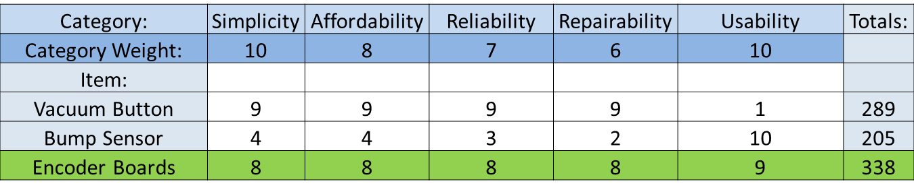

**Figure 11:** Grip sense decision matrix.